4/19/2017

- TRIGGER II results by date 19 April 2017
Dear colleagues, the 48-hour operation TRIGGER II finalized on 8 April 2017. During the operation Stockholm was hit by a terrorist attack and our Swedish colleagues had to shift operational priorities to their national needs.

Seizures included 321 firearms (including rocket launcher and machine gun), more than 19 500 pcs ammunition, over 50 grenades and other explosives.

Over 7 842 police staff worked together in the European Region within 375 national operations and 101 cross-border operations. They checked 178 334 persons, more than 40 212 vehicles and 7 vessels. More than 2300 parcels were checked at postal hubs.

Thus far, 149 persons are known to be arrested, from that 47 persons related to firearms offences.

The iARMS database was used for 139 queries, 25 tracing requests.

189 cases of drug seizures - biggest hits: 350 kg of poppy seed and 85 kg of marihuana
134 pressed packages were seized and 4 vehicles were seized as means of transport.

One thief-in-law was arrested, INTERPOL’s MILLENNIUM database was used and populated in 17 cases. We now get a clearer picture of some of the criminal relations.

Approx. 170.000 EURO was seized and a criminal investigation initiated.

The 48hrs operation ended Saturday 8 April 15.00 Hrs.

- FIND BELOW SOME STATISTICS:

TRIGGER II Report form | 23 Countries, 6-8 April 2017 | Results
Operations | Number of operations in the countries launched within TRIGGER II: | 503
 | From that: number of cross-border operations | 101
Staff | Number of officers | Over 7842
Persons: | Number of persons checked: | 179 862
 | Number of vehicles checked | 41 925 + 7 Vessels
 | Number of arrests suspected Firearms | 47
 | Number of arrests suspected other | 102
 | Number of arrest warrants executed | 38
Firearms: | Number of firearms recovered: | 321 Firearms +  19 518 pcs ammunition
 | Number of firearms searched in national databases: | 330
 | Number of firearms searched in iARMS: | 139
 | Number of Hits within iARMS searches: | 0
 | Number of tracing requests : | 38
Illicit Drugs | Numbers of drug seizures | 189
 | Numbers of seizure messages submitted to INTERPOL | 40
 | Numbers of “pressed Packages” | 134
 | Numbers of seized means of transport (Vehicles, vessels….) | 4
 | Numbers of further intelligence provided to INTERPOL’s drugs unit | 5
Thieves-in-law | Numbers of arrests based on MILLENNIUM database | 1
 | Numbers of tracing requests based on MILLENNIUM database | 11
 | Numbers of further intelligence provided to MILLENNIUM database | 7
Further | Number of records issued (other databases) | 51
 | Number of searches (other databases) | 455
Documentation | Number of complaints | 2
 | Local press reports | 5 (publications on local web platforms)

- RESULTS ASF DURING THE OPERATION TIME 6-8 APRIL

23 TRIGGER II Countries 6-8 April 2017 related to the timeframe 7-9 April 2016
Nominal searches 4.652.885 related 3.365.864
Hits: 1215 related 1104
SMV searches: 1.488.439 related 1.013.639
Hits: 521 related 629
SLTD searches: 3 858 686 related 2.241.056
Hits: 943 related 87

- STAFF AND INTERPOL OPERATIONS CENTER

Unit
GORS EUR (24/7) | 4
Firearms Programme | 2
Millenium & FPDM | 1
DCO | 2
Europol | 1
WCO | 1
FPDM | 4

- ACTIVITIES DURING THE OPERATION:

GORS:
1200 e- mails processed within the preparation, 1500 e-mails processed during the operation
- set up and run INTERPOL Operations Center
- provide the coordinators to the Regional Coordination Hubs and 24/7 permanence
- coordinate and steer communication between INTERPOL units, Regional Hubs and further countries Zone 2

INTERPOL Firearms Programme:
- Provide support for iARMS, IBIN, The Firearms recovery protocol, the questionnaire
- Initiate and coordinate further investigation and cooperation
- Crosscheck requests

MILLENIUM with CAS
- Liaise with partner countries, initiate further investigation and intelligence to populate its database
- Crosscheck search requests (incl. the CAF for CT).
- INTELLIGENCE collection
All the persons metioned in the Operation Trigger II were checked against ICIS and the MILLENNIUM Analysis file. There were 9 nominal hits in relation to 3 (specific MILLENNIUM) requests.
3 requests for check in relation to Project MILLENNIUM:
  - 1.Swedish request for check of firearms links to TIL community – 13 nominals were checked, 3 hits – 1 TIL and 2 Millennium entities.
  - 2.Ukranian request for check of a known thief-in-law (TIL) with valid Green Notice issued by Georgia. The person entered Ukraine on 06/04/2017. The person who met him at the airport was checked through INTERPOL FILES with a negative result.
  - 3.Ukranian request for check of 5 Moldavian nationals recorded in ICIS in relation to Project MILLENNIUM with recent travel activities in Ukraine. The 4 persons are known to be members of a criminal organization led by a TIL and one person is connected to SOLNTSEVSKAYA OCG

MILLENIUM got back to the Ukraine, Sweden, Moldova for follow up on the information, trying to gather more intelligence. Further specific MILLENNIUM contacts to Germany, Finland and the UK

- Europol: Use of Europol Mobile office to crosscheck with Europol’s databases.
109 searches in common:

Date | Person | Weapon | Communication | Documents | Transportation | Location
06/04/2017 | 7 |  | 14 | 2 | 2 | 3
07/04/2017 | 24 | 8 |  | 10 | 4 | 2
08/04/2017 | 17 | 4 | 1 | 3 | 4 | 4

FPDM: Close cooperation with INTERPOL’s Operations Center: ICIS, SLTD and SMV checks & support MILLENNIUM.

- Find below a selection of small and big success stories during our operation TRIGGER II

PRE – OPERATIONAL PHASE:

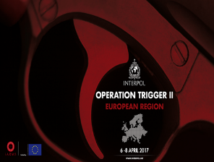
Firearms/Drugs 18.03.2017 NCB Podgorica/NCB Tirana:
Montenegrin border police, on border crossing point Sukobin, in an albanian bus Setra, driving from Tirana-to Dortmund, in the bus luggage there were found 3 plastic bags with marihuana, ca 1547gr and 7 pistols, along with 30 bullets. Further investigation exposed a forged Italian ID card, found in the jacket pocket of a driver, with intention to be delivered to certain person also in Dortmund, Germany.-4- male suspects involved: 3 ALB Nationals and one XKS national. Parallel tri-lateral investigation (Montenegro, Germany, Albania) is ongoing.

Firearms 20.03.2017 NCB Bern: Theft of 10 firearms out of the safe of a shooting range. TRIGGER II countries and further Zone 2 countries are requested to search and find these weapons. Population of the iARMS database as well as ballistic information to IBIN shall be processed ASAP.

Drugs/ Red notice 01.04.2017 14.30: NCB Skopje: South Hub: BCP “Bogorodica” (GR-MK). One person arrested in reference of a Red Notice and suspect of transporting drugs by use of a prepared bunker in his vehicle. Red Notice IP ANKARA, Person detained, vehicle seized. No extradition as the person has MKD nationality. Further checks in Austria for verification of documents.

Firearms 05.04.2017 at 06:45h NCB Sofia: BCP “Kulata-Promachon –exit: A vehicle Peugeot l/p: СО8711ВР was stopped for border checks. The car was driven by a BGR national. During the check in a hidden compartment on the car’s floor 7320 combat cartridges with writing on the cartridge case 70/10 were found together with pistol make GLOCK, model 23. During a search of the handbag of the female bulgarian passenger, a pistol silencer found. The two persons have been put in custody and a pre trial case was initiated. The pistol and the ammunitions were seized.

Foreign currency violation 06.04.2017 at 12h NCB Beograd: at the BCP Gradina (on exit from Serbia), customs officials found EUR 65,000 in possession of a passenger. As two passengers were in the vehicle, they were returned each EUR 10,000 respectively, and the remaining EUR 45,000 were kept until the conclusion of proceedings regarding foreign currency violation.

Migrant smuggling 06.04.2017 at 11h, NCB Beograd: at the BCP Batrovci (on exit from Serbia), upon search of a heavy goods vehicle with BGR l/p, 3 migrants were found in the cargo space.

Migrant Smuggling 06.04.2017 at 11.30h, NCB Beograd: at the BCP Batrovci (on exit from Serbia), upon search of a heavy goods vehicle with MKD l/p, 7 migrants were found in the cargo space.

Migrant Smuggling 06.04.2017 at 12.00h, NCB Beograd: at the BCP Batrovci (on exit from Serbia), upon search of a heavy goods vehicle with TUR l/p, 2 migrants were found in the cargo space.

Drugs 06.04.2017, NCB Athens: Police investigation conducted by the anti-drugs unit of Iraklion showed that the suspect kept an amount of unprocessed cannabis in his home. In the morning hours of 06-04-2017 undercover police officers traced him outside his place of residence and performed a home search along with a judicial officer during which there were found in his yard: a) 2 cannabis saplings diligently cultivated 30cm each, b) 10gr. of unprocessed

OPERATIONAL PHASE:

Firearms/Drugs 06.04.2017 NCB Sarajevo: Police forces of Gradiska PD during a search, seized 4 guns, 13 hand grenades and minor quantities of marijuana and cocaine in town Gradiska. Also larger quantity of ammunition is being found and seized in the same case. Further details are expected to be provided later. | 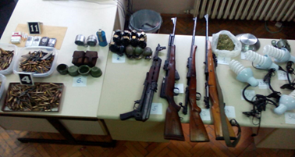
Firearms 06.04.2017, NCB Bern: a passenger was checked on train EN466 (Budapest-Vienna-Zurich), near Zurich, who during the check attempted to hide a firearm beside his seat. The person was arrested. Seized handgun Glock 25, 9mm, (Serial Nr. currently unknown) was ground away.

Firearms, 06.04.2017, NCB Zagreb: On 06.04.2017 a murder was committed by an unknown suspect, using a pistol make Crvena Zastava, cal.7,62, serial nr.J-128232. The pistol is registered in HRV and has been reported as stolen on national level since 2015. The weapon is seized. The investigation is ongoing.

Drugs 06.04.2017 16.35 NCB Skopje: At BCP "Tabanovce” (MKD/ SRB), a Vehicle BMW was checked, the MKD driver suspected drugs trafficking. The investigation is ongoing.

Drugs 06.04.2017, NCB Prague: In Mlada Boleslav, a CZE National is checked possessing drugs (21g Cannabis)

Ammunition, grenades, explosives seized 06.04.2017, NCB Minsk: in close vicinity to state border of Belarus with neighboring states by the Belarusian border guard authorities:
- at Gomel region 34 detonators, 9 percussion fuses and 3 mortar mines of WW2 were detected and destroyed, a grenade of WW2 was detected and seized
- at Vitebsk region a shell of WW2 was detected and seized;
- at Grodno region a shell of WW2 was detected and seized;
- at Brest region 4 cartridges of 20mm caliber, 1 cartridge of 16mm caliber, 1 cartridge of 12mm caliber, and 1 smoke bomb “ПГ-2РДП” were seized;

Firearms/ Drugs 06.04.2017, NCB Beograd: Within inland searches, 1 machine gun model M52 was seized with a frame and two cartridges. Two sprouted cannabis plants were found, 2 and 3 cm high and 19 cannabis seeds two 5 cm cannabis plants were detected, 50 tablets Tromadona, -1,76 g Marihuane, -2,08 LSD-29 tablets LEHAURIN Bromazepan

Thief-in-law – entered, NCB Kiev: on 06/04/2017 through Lviv airport. A UKR national, met him at the airport. Persons known – intelligence gathering for MILLENNIUM.

Ammunition, hand grenades, explosives seized 06.04.2017, NCB Kiev: According to received information on 06/04/2016 as the result of joint actions State Border Service and National Police at Luhansk region, at windbreaker it was found 200 gr. of explosive, 7 hand grenades and & 400 bullets.

Drugs 06.04.2017, NCB Kiev: Kherson region, National Police seized 5 kilos of marihuana and 70 gr. of amphetamine. One UKR national arrested.

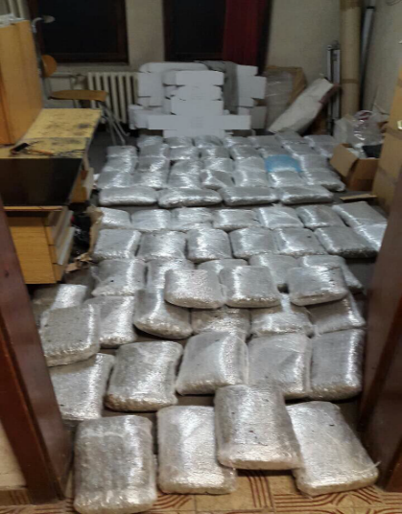
Drugs 06.04.2017, NCB Podgorica: Police seized 85 kg of marihuana during control of a vehicle and on that occasion arrested two persons. During search police found two white sacks, one on the back seat and second in the trunk. In the sacks found 72 packages of cannabis, in total weight 85 kg. The drugs were intended to the market of the neighbor countries.

Firearms and Drugs 06.04.2017, NCB Podgorica: Second case, within the same police action during house search of a Montenegro national in Podgorica was found 20 PVC packages of cannabis, in total weight 20 kg. During search the following weapon and ammunition was found: one hunting rifle, unknown make, cal.12mm, fabrique number 125934; 4 bullets for hunting rifle cal.12mm; 12 bullets for smallcalibre rifle, cal.12mm; 23 bullets cal. 44 Magnum; 7 bullets cal.9mm.
There were other objects found during search as well: 1 scale for precise mesurement, unknown make; 2 mobile - 1 sim card; 3 pairs of license plates (BiH). During search police found in house a BiH national.

Drugs 06.04.2017, 18.22, NCB Sofia: an alert Narcotics trafficking was submitted: 4 BGR nationals are suspected to transport drugs in a Land Rover most probably be hidden in the vehicle’s tank). NCB Athens and NCB Ankara requested for support. Furtherly a BGR lorry type, Volvo driven by BGR national - searched for the same offence.

Thief-in–Law 06.04.2017 19.57, NCB Kiev: Arrest of a Thief-in law searched by a valid diffusion from NCB Moscow. Investigations ongoing

Firearms 06.04.2017 17.13, NCB Moscow: an alert from the Police St. Petersburg was submitted for support to dismantle an international criminal group trafficking illicit deactivated WW I and II weapons via a network of Traffickers and re-activators mainly in the Baltic Region. NCB Oslo, NCB Tallin, NCB Helsinki, NCB Bratislava and NCB Stockholm are requested to support. Investigations are ongoing

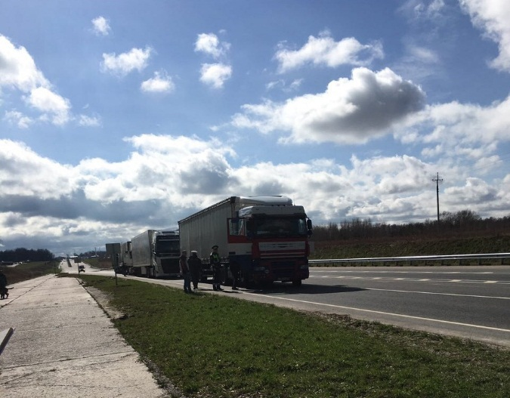 | 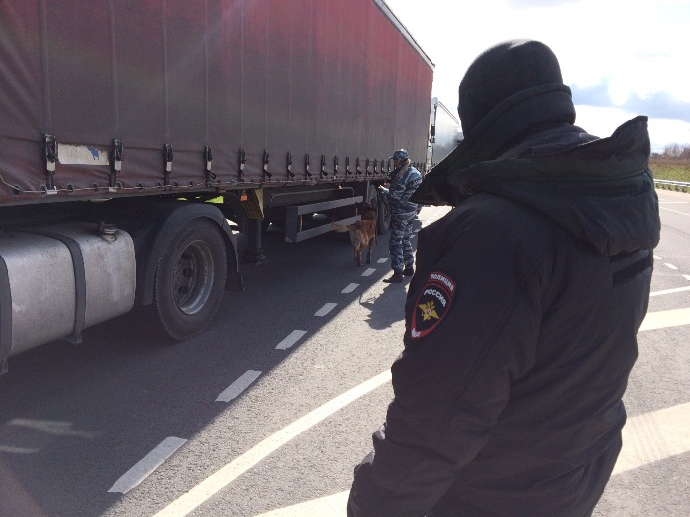
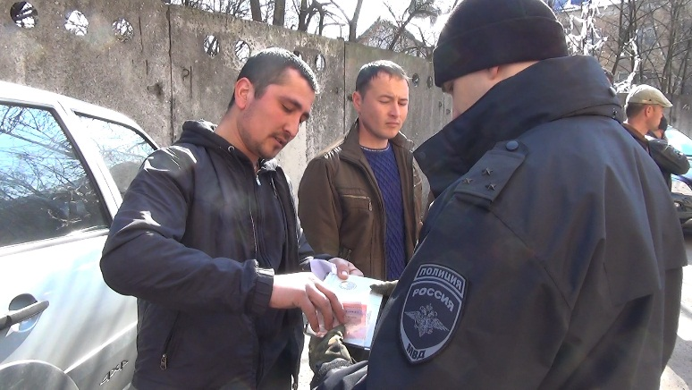 | 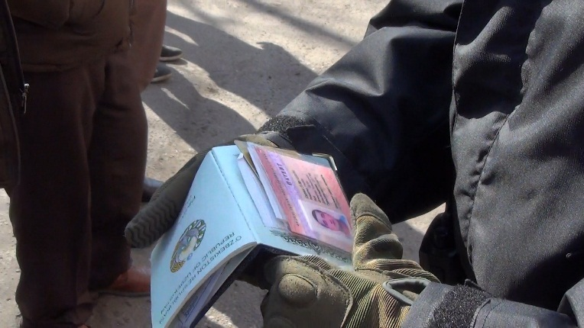
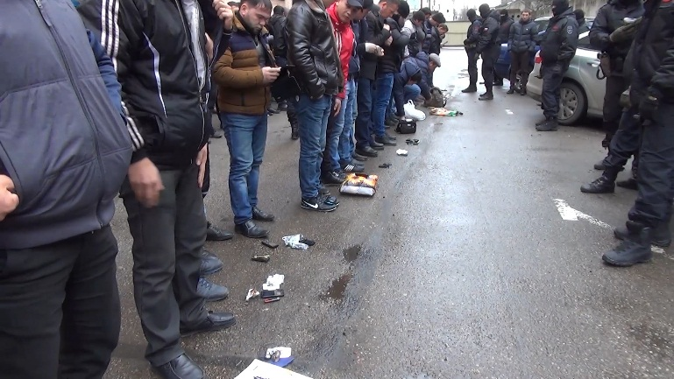 | 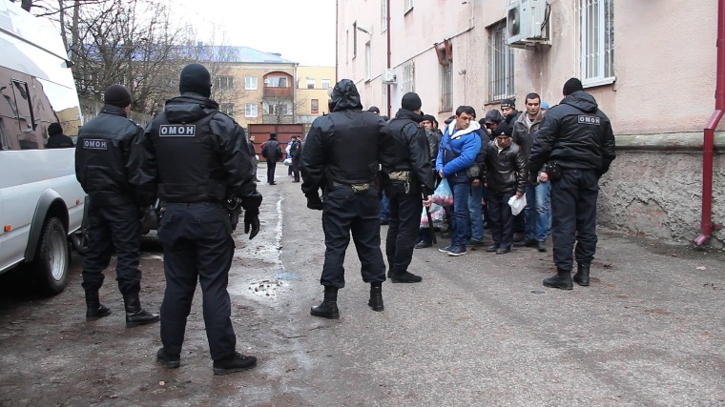
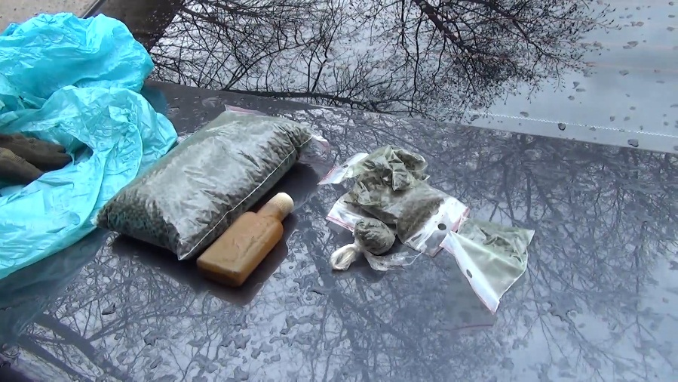 | 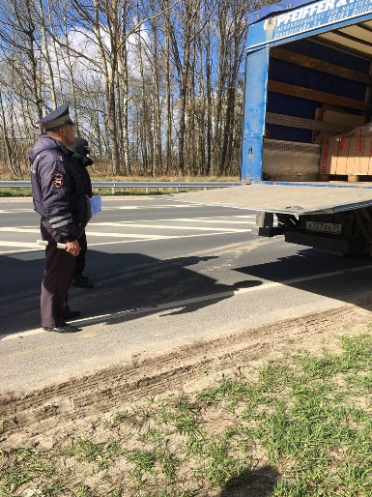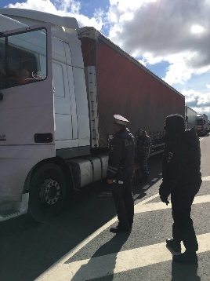
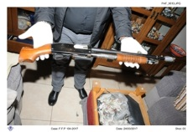
Firearms, arms 06.04.2017, NCB Nicosia: Crime Investigation Department has contacted an intelligent led operation with indigence provided from local sources in Paphos. During the operation were found and seized the following firearms and ammunitions A pistol with a silencer and six cartridges full metal jacket – the pistol was “LLAMA” ESPECIAL with serial number 254962, caliber 0.22, A Shot gun with markings “AMERICAN EAGLE” MODEL 602H, gauge 20. Its stock was cut off. A hand crossbow of unknown make with one arrow. The involved person, GBR citizen was arrested for the possession of the above firearms and ammunitions. iARMS Trace request will be send to you countries, too.

Drugs/ Cybercrime 06.04.2017 18.11 NCB Moscow: an alert was submitted from the Chelyabinsk Police investigating in an international case of drugs sale via the Viber app. Czech Republic, Denmark, Spain, Sweden, Ireland, Germany are involved. Apart the checks of the specialized units INTERPOL Operations Center requested operational support of the IGCI to detect IP addresses.

Firearms/ Thieves in Law, drugs, OCG, radical islamism 06.04.2017 19:32: NCB Stockholm submits intelligence collected since 2007 on a criminal group mainly BLR/RUS origin: 14 persons (some of them crowned TiL) acting in firearms trafficking, different crime areas and being involved to radical Islamism. NCB Stockholm asks any information available on the persons, their known whereabouts and criminal connections.

Arrest warrant executed, 06.04.2017 NCB Sarajevo: One person was arrested by Zenica-Doboj canton police. Notices were issued against him by INTERPOL Vienna and INTERPOL Sarajevo for criminal offence of Aggravated Theft. Information on possible location was received in TRIGGER II coordination center in B&H and the same was forwarded to Zenica-Doboj canton police. Based on received information he was in Kakanj, Zenica – Doboj Canton, hidden in one family house, possible armed. Special police forces surrendered house and then the wanted person surrendered himself to the police.

Seizure of weapons, 07.04.2017, NCB Athens: During police investigation in Korfy (Kerkira), regarding a suicide case, 5 pieces of weapons were found: S/N 42119 single-rifle, make"L. FAISAN", diam. 16 cal; S/N 18539 single-rifle hunting weapon, make "SARASQUETA", diam. 16 cal; S/N 796600 flobert, unknown make, diam. 9 cal; S/N 8912848, non-working hunting rifle, make "BAIKAL", diam 12 cal and S/N Ν41691Ε, shotgun, make "BERETTA A303". All mentioned weapons were illegally possessed by the deceased and were seized.

Drugs 07.04.0217 12.00 NCB Ljubljana: 32 kg of Marihuana seized at BC. Person was entering SLO (from HRV) with a vehicle make Peugeot type 307. Within the border control a hidden compartment was found under the co passenger’s seat. In this compartment there were several brown rolls, probably containing marihuana. According to the suspect there were app. 32 kg of marihuana. He is currently in detention and will be interrogated by the investigative judge. In a second case a small amount – 10 g of marihuana was found.

DRUGS 07.04.2017 NCB Nicosia: the Crime Prevention Unit with traffic Department have conducted road policing searches in Larnaca. During the searches were found and seized the following drugs and items: 30 gr (cannabis); One electronic balance scale, 1470 euros in cash. Involved person was arrested for the possession of the above drugs and cash.
Checks in postal Hubs NCB Nicosia: Customs and Postal Services during the whole operation have conducted 2379 parcels searches.
Ammunition recovered, 07.04.2017 , NCB Minsk: By the Border Guard Authorities of Belarus at Vitebsk region a machinegun belt with 20 cartridges of WW2 was detected and seized.

Firearm recovered. 07.04.2017 19:34 NCB Zagreb: Police officers during investigation of Illegal stay of several foreigners, recovered one semiautomatic rifle make “Crvena zastava” cal 7.62 serial No.: E-114647. Investigation is still ongoing and there are no known suspects yet.

Thieves-in –law Alert/preliminary check 07.04.2017 NCB Kiev: on request NCB Kiev checks of 5 persons (MDA citizens suspected thieves-in-law- linked to MILLENNIUM or wanted by MDA authorities) were checked and intelligence from other countries was provided concerning movements, offences as well as attached OCGs.

Firearms seized 07.04.2017 NCB Baku: pistol MP 654, cal. 4,5 mm, was discovered in a luggage of an unknown person at the border in Samur with RUS.

Millennium/Firearms/Cash seizure, NCB Stockholm, 6-7.04.2017:
- 10 internal intelligence reports were written as a direct result of the operation. Two reports were reported into the TRIGGER II operation regarding Andrei Kalasnikov (carrying 5 soft airguns) and Andrei Kalinouski (linked to TiL). One (Kalinouski) is to be seen as contribution to the Millennium database.

- One processing of information in preparation for the Operation gave that two suspects had driven a car to Riga in January that was later reported stolen. Further checks with the ferry lines showed that they had similarly taken three other vehicles out of the country since 2014 that were subsequently reported stolen. An additional crime report was written listing the two as suspects: AKHMEDOV, Erkin dob 12.01 1981 citizen of Kyrgyzstan and ISAKOV, Sherzodbek dob 30.05 1983 (unknown citizenship).

- Two as part of the stand by mission for Arlanda airport, one of the Trigger teams was called there because of a passenger trying to take a larger amount of cash out of Sweden. Suspect; Swedish citizen ABDO, Waisi 10.11 1979. No arrest was made but the cash (1,76 million SEK = aprox 170.000 EURO) was seized and a criminal investigation initiated.

- Information on eight recovered firearms (pistols) will be sent through Trigger channels to Bosnia Hercegovina. The actual seizure was made on March 18th on board a bus arriving from Sarajevo. Information in the ongoing investigation has already begun over Europol channels. However, considering the content of the planning meeting in Minsk, information around the weapons will be submitted through Trigger in order to stimulate tracing procedures and other important aspects around the handling of recovered firearms. No tracing has been done via iArms yet as the immediate origin before Sweden is known.

Drugs seized 08.04.2017 NCB Tirana: at BCP Kafasan/Korce a BGR national was arrested when trafficking 6 kg cannabis in a vehicle bearing BGR l/ps.

Drugs 08.04.2017, NCB Minsk: Brest police seized 350 kilograms of poppy seeds stored in garage owned by Belarusian national.

Voluntary surrender of total 33 pieces of firearms (among them 10 sub machine guns, 4 rifles Mod 63 Cal 7,62, 3 rifles -MOD 56 7,62 MM). The firearms were provided to ALB authorities. Checks in process. Searches currently without hit.
Trafficking of militaria 08.04.2017 EST- FIN (Cross-border action) EST Customs and Border authorities checked a vehicle in Tallinn that intended to enter the Ferry to Helsinki. The vehicle was staffed with 4 RUS nationals. Several bayonets, swords, knives, magazines for automatic firearm and also allegedly armor piercing launchers and ammunition moulages with educational purpose. One of the mentioned devices was seized for further investigation by EST authorities. FIN customs authorities were informed about their possible arrival to FIN. Further investigation during the ferry transfer

Confiscation of goods, 08.04.2017, NCB Tirana: At BCP Kakavije/Gjitokaster (GR/AL border),
7 tons of smuggled goods (chocolates, biscuits etc) have been confiscated. The goods were transported in a truck with ALB l/ps.

Drugs 07.04.2017, NCB Tallin Customs work in postal hubs 7 different postal packages were examined and narcotic sustances were found:
1. 7,6 g compressed substance, colur brown (most likely hashish)
2. 101 pc of tablets (colour: pink)
3. 2 pc pc of tablets (colour: pink)
4. 4,1 g greenish-brownish plant parts (most likely marijana)
5. 28,6 g beige-colored particulate material (XTC rapid test responded positively)
6. 10,2 g beige-colored particulate material (XTC rapid test responded positively)
7. 10 pc of tablets (colour: gray, Domino markings on them)

TRIGGER II Cross-border activities Bulgaria to neighbor states: The Bulgarian Border Police intensified vehicle and train checks on 4 Border crossing points to Serbia, Turkey and Macedonia
I. BCP “Kalotina” II. BCP “Kapitan Andreevo” III. BCP “Gyueshevo” IV. BCP “Lesovo”
252 vehicles and 8 Trains and in common 4225 persons were checked; 306 cartridges for pistol make “Makarov” were seized.

- Follow ups:
- Compile an operation report
- Follow up ongoing investigations
- Share intelligence within the frame of the data owners.
- Debrief, amendment of the planning and preparation processes.
- Start new planning.

Thanks all for the cooperation

Bernd Günther John Hageman

